He’s Macro . He’s come from Italy. He is Khae’s Colleague. He works in marketing.He lives in a studio apartment.He rides motocycle to work when It’s He wants to design a product that everyone can use

He’s John Berry. He’s come from American .He’s Mrs Berry’s son.

He’s Benny’s neighbor. He is a filmmaker.

**She’s Sofi. She is a cook. She works at the restaurant. She takes a bus to work. Her grandmother is a great cook.**

He’s Tod. He’s come from American. He’s 40 years old. His hair is short and gray .He is a supervisor at the Company Company.Khae, Marco and Aanya don’t like him.

She’s Khae. She is come from Thai.She’s a product designer at the company company. Her parents has a noodle shop. She has a brother.

She’s Khae. She is come from Thai.She’s a product designer at the company company. Her parents has a noodle shop. She has a brother.

**She’s Aanya. She is an Engineer.She works at the company company. Her parents lives in India.She has a big family.She has one sister and three brothers.**

**She’s Khae. She is come from Thai.She’s a product designer at the company company. Her parents has a noodle shop. She has a brother.**

**He’s Shen. He lives with Benny. He doesn’t have a job. But He wants to be an actor.**

**Shen was in China before he was in the United States**

**He’s Benny. He lives with Shen. He was a salesperson at a computer store in England.His hobbies is watch football. His mother is a English teacher.**

**1.1**

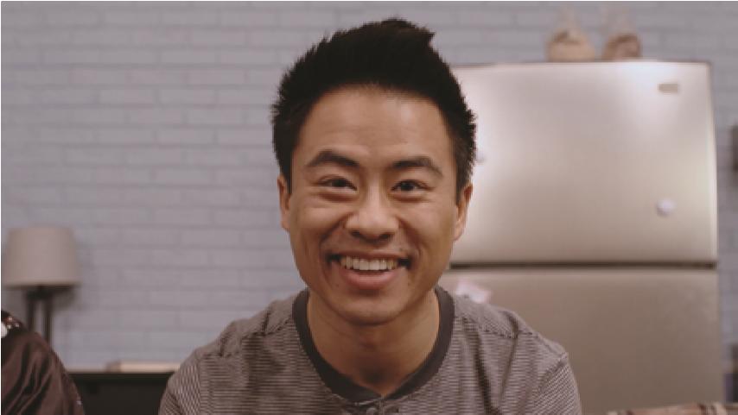

**1.1**



**1.1**



**1**

**/**

**2**

**A**

**2.1**

+

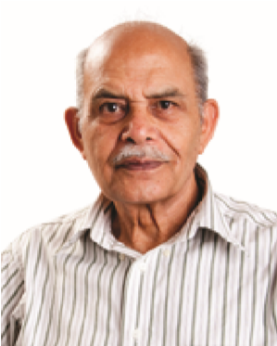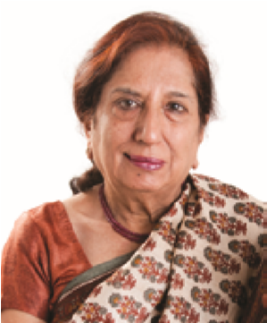

+



+



**2.1**

**B**

***Work with your partner to answer the questions.***

. Your parents’ son is your

1

.

2

. Your son’s sister is your

.

3

. Your father’s mother is your

.

. Another word for “father” is

4

.

. Your mother and father are your

5

.

. Your sons and daughters are your

6

.

. Your father’s daughter is your

7

.

. Your daughter’s brother is your

8

.

**2.1**

**B**

***Work with your partner to answer the questions.***

. Your parents’ son is your

1

.

2

. Your son’s sister is your

.

3

. Your father’s mother is your

.

. Another word for “father” is

4

.

. Your mother and father are your

5

.

. Your sons and daughters are your

6

.

. Your father’s daughter is your

7

.

. Your daughter’s brother is your

8

.

**2.1**

**B**

***Work with your partner to answer the questions.***

. Your parents’ son is your

1

.

2

. Your son’s sister is your

.

3

. Your father’s mother is your

.

. Another word for “father” is

4

.

. Your mother and father are your

5

.

. Your sons and daughters are your

6

.

. Your father’s daughter is your

7

.

. Your daughter’s brother is your

8

.





**3.2**

often

everyday

sometimes

always

never



Mondays and Wednesdays



Monday to Sunday

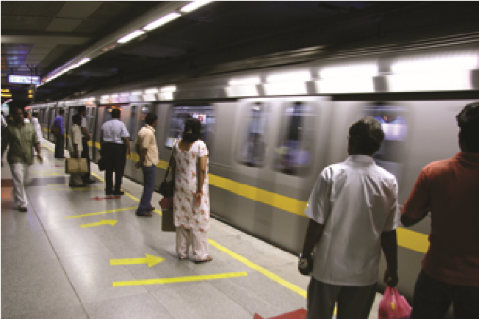

Monday to Sunday



Saturdays and Sundays



Saturdays and Sundays



Fridays



***Use the pictures and time to ask your partner: Do you . . . ?***

**3.2**

often

everyday

sometimes

always

never



Mondays and Wednesdays



Monday to Sunday



Monday to Sunday



Saturdays and Sundays



Saturdays and Sundays



Fridays



***Use the pictures and time to ask your partner: Do you . . . ?***

**3.2**

often

everyday

sometimes

always

never



Mondays and Wednesdays



Monday to Sunday



Monday to Sunday



Saturdays and Sundays



Saturdays and Sundays



Fridays



***Use the pictures and time to ask your partner: Do you . . . ?***

